**RESIDENTIAL PROPERTY BUYERS**

**UNDERSTANDING THE DEMOGRAPHICS**

**Residential Property Buyers**

**Understanding the demographics**

# **Summary**

The dataset provides a rich source of information for analyzing the housing market, particularly how various factors like income, sale prices, buyer demographics, and regional differences influence property sales.

Using various SQL queries we can gain deep insights into trends, correlations, and key real estate market drivers across different provinces and buyer segments.

# **Tables & Schema (ERD)**

* **Buyers’ Group Table:** Contains the data for buyers' group information, which can be the person buying the property on his own (Single), as a couple (Paired), or in a group of 3 or more.
* **Buyers’ Char Table:** Characteristics can be whether the person is a male, female, immigrant, or a non-immigrant.
* **Buyers’ Status Table:** Lookup table for first-time home buyers & the seasoned ones.
* **Province Table:** Keeps the data for different Canadian provinces.
* **Average Family Income Data:** Data from 2019-2020
* **Average Sale Price Income Data:** Data from 2019-2020
* **Number of Properties Sold**: Data from 2019-2020

# **Entity Relationship Diagram (ERD)**

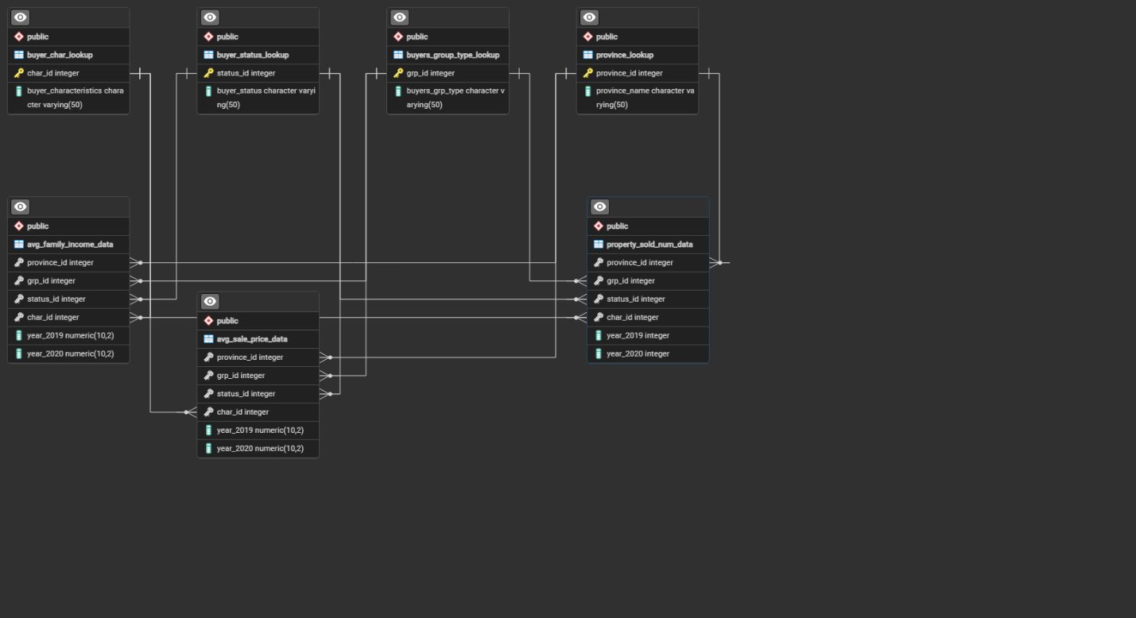

The Entity-Relationship Diagram (**ERD**) represents a relational database focused on analyzing property buyers, sales trends, and financial data across provinces.

It includes lookup tables for provinces, buyer characteristics, group types, and statuses, which are linked to key data tables tracking average family income, sale prices, and property sales for 2019-2020.

These connections allow detailed analysis by integrating geographic, demographic, and economic factors, enabling comprehensive insights into buyer behavior and market trends across different regions.

# **Insights**

## **Average Income by Province**

* **New Brunswick** has the highest average family income in both 2019 and 2020 at **$120,416.66**.
* **Manitoba** has the lowest average family income in both years at **$72,656.25**.

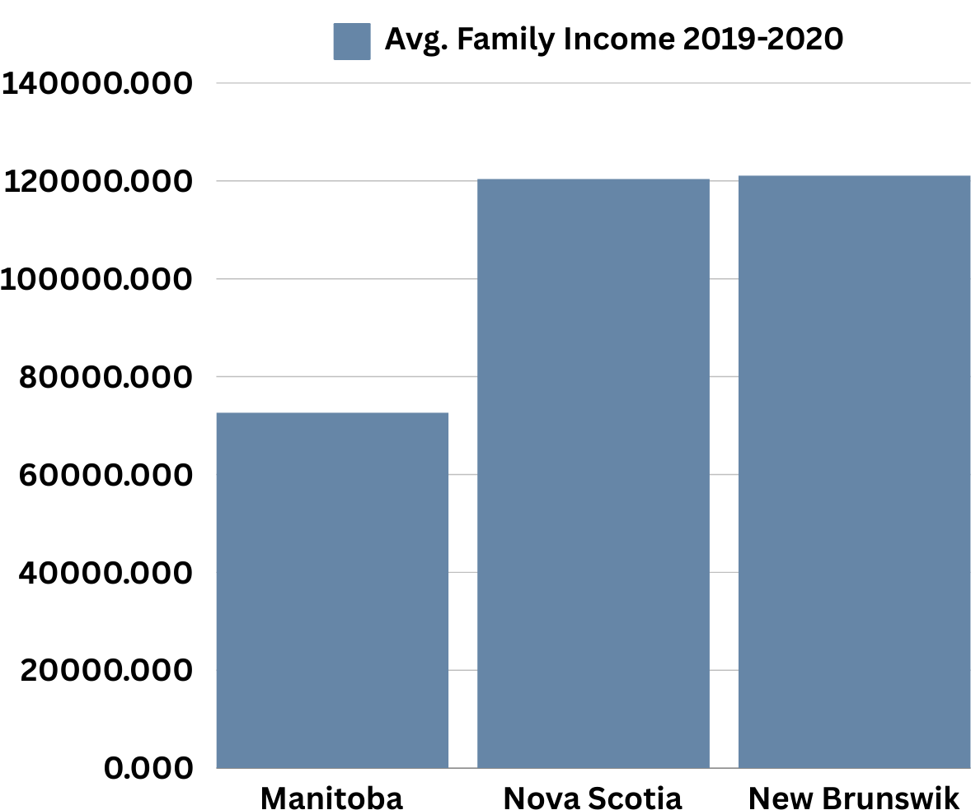

**SQL QUERRY:**

------------------------------Avg Incomoe By province -------------

SELECT

p.Province_Name,

AVG(f.Year_2020) AS Avg_Income_2020

FROM

Avg_Family_Income_Data f

JOIN

Province_Lookup p ON f.Province_ID = p.Province_ID

GROUP BY

p.Province_Name;

## **Average Sale Price by Buyer Status**

* **First-time** home buyers pay higher prices on average **at $322,781.  
    
    
  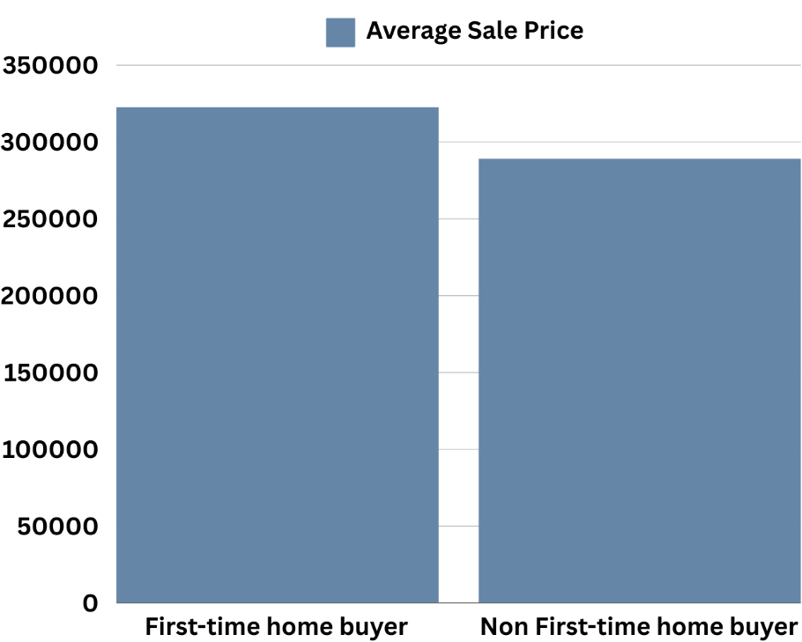**

**SQL QUERRY:**

SELECT

b.Buyer_Status,

AVG(s.Year_2020) AS Avg_Sale_Price_2020

FROM

Avg_Sale_Price_Data s

JOIN

Buyer_Status_Lookup b ON s.Status_ID = b.Status_ID

GROUP BY

b.Buyer_Status;

## **Average Sale Price by Province**

* **New Brunswick** has the highest average sale prices at **$374,541.32.**

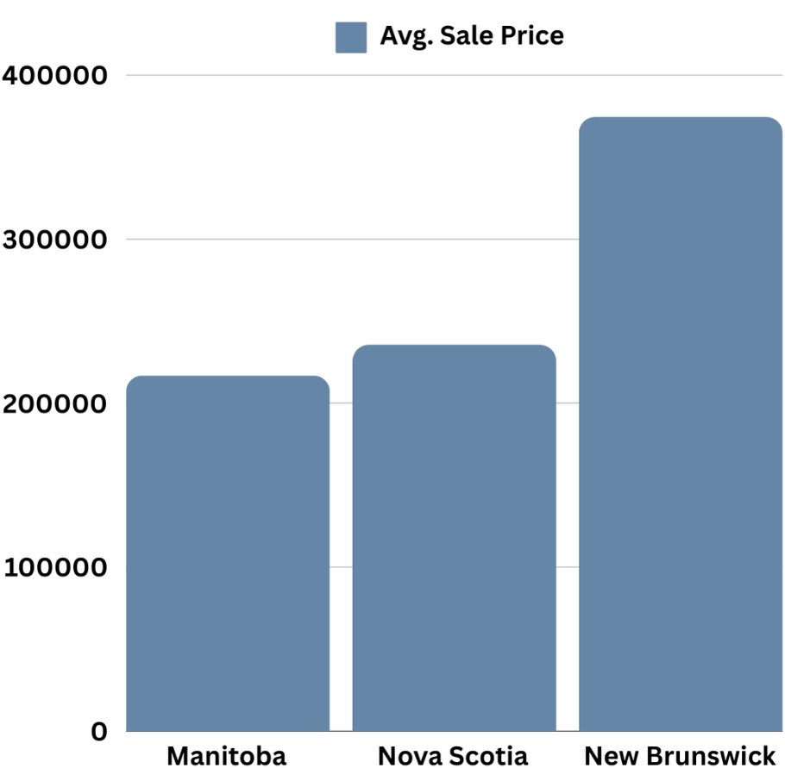

**SQL QUERRY:**

SELECT

p.Province_Name,

AVG(s.Year_2020) AS Avg_Sale_Price_2020

FROM

Avg_Sale_Price_Data s

JOIN

Province_Lookup p ON s.Province_ID = p.Province_ID

GROUP BY

p.Province_Name;

## **Change in Average Sale Price by Province**

* **New Brunswick** saw the largest increase in average sale price at **$27,597.22,** while **Manitoba** experienced the smallest increase at **$4,375.**

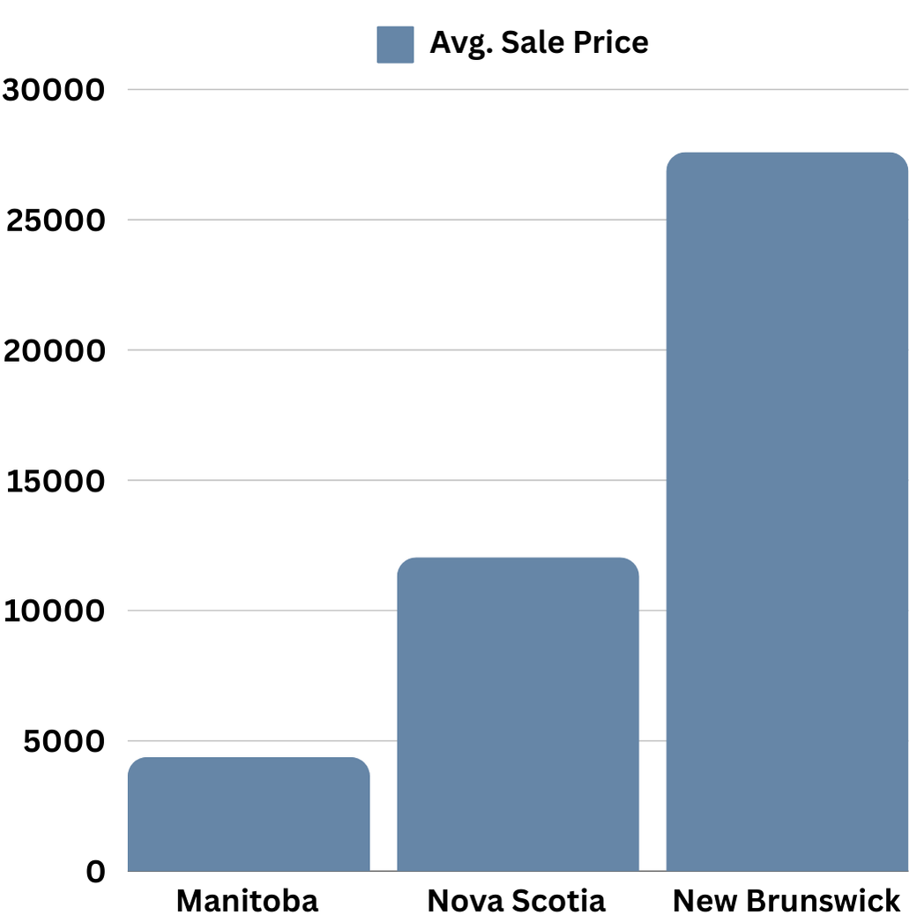

**SQL QUERRY:**

SELECT

p.Province_Name,

AVG(s.Year_2019) AS Avg_Sale_Price_2019,

AVG(s.Year_2020) AS Avg_Sale_Price_2020,

(AVG(s.Year_2020) - AVG(s.Year_2019)) AS Price_Change

FROM

Avg_Sale_Price_Data s

JOIN

Province_Lookup p ON s.Province_ID = p.Province_ID

GROUP BY

p.Province_Name;

## **Buyers’ Insight**

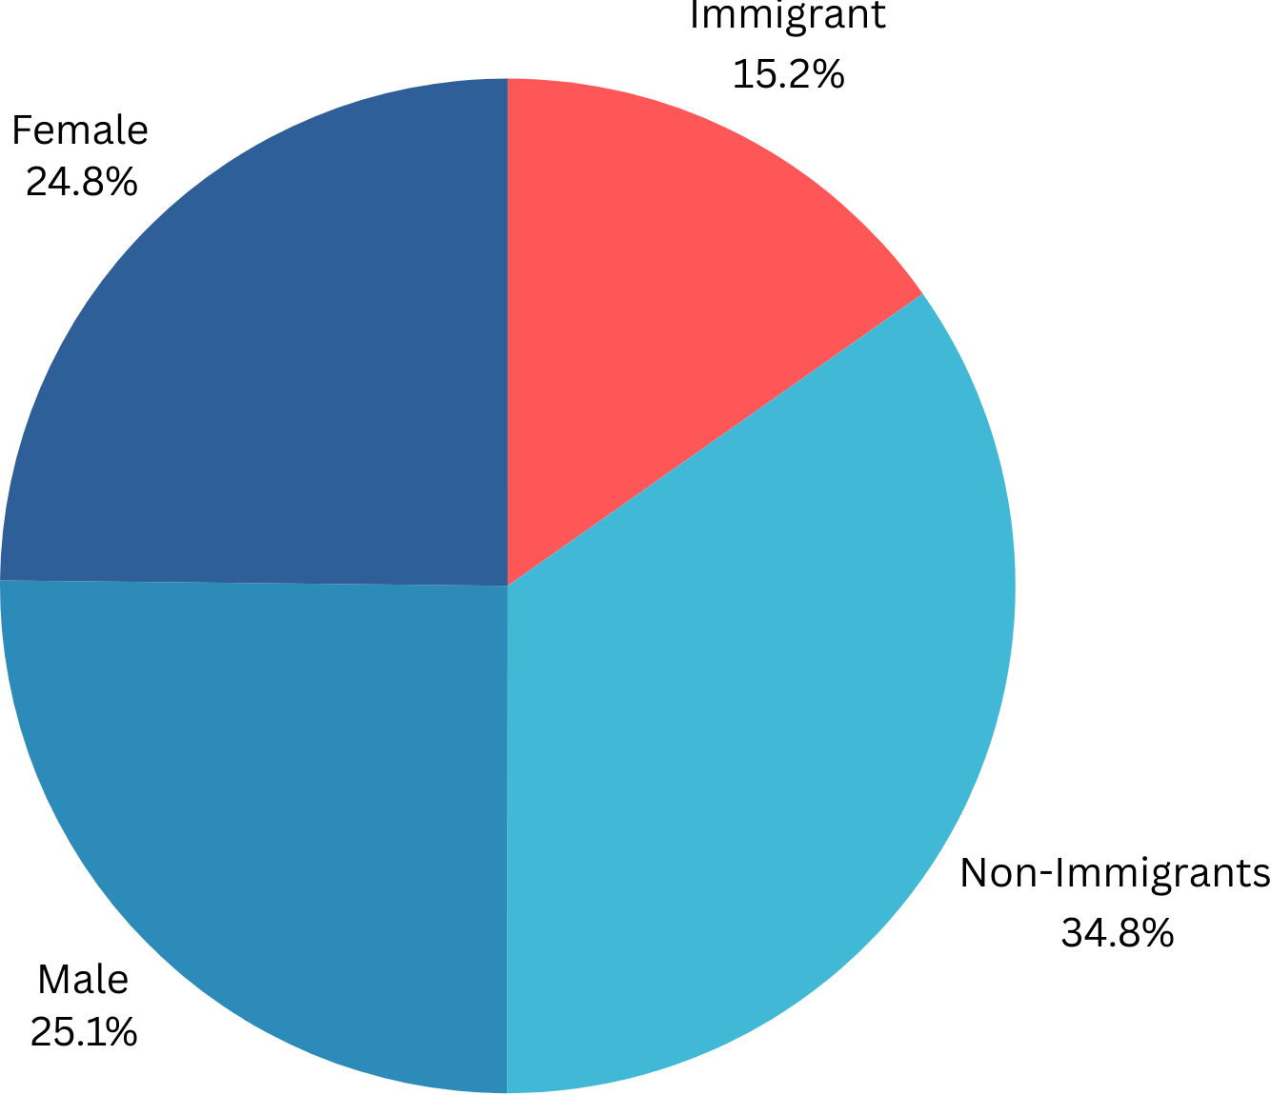

The % of **immigrant** property buyers compared to non-immigrant buyers in 2020 is approximately **15%.** i.e for every non-immigrant buyer, there are about 0.19 immigrant buyers.

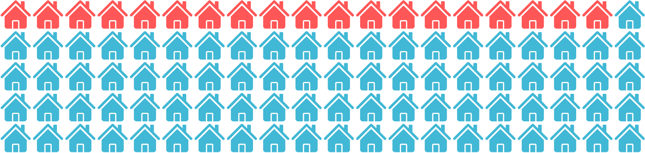

**SQL QUERRY:**

-- Total number of Immigrant buyers from 2019 to 2020

SELECT

SUM(Year_2019 + Year_2020) AS Total_Immigrant_Buyers

FROM

Property_Sold_Num_Data

WHERE

Char_ID = (SELECT Char_ID FROM Buyer_Char_Lookup WHERE Buyer_Characteristics LIKE '%Immigrant%');

-- Total number of Non-Immigrant buyers from 2019 to 2020

SELECT

SUM(Year_2019 + Year_2020) AS Total_Non_Immigrant_Buyers

FROM

Property_Sold_Num_Data

WHERE

Char_ID = (SELECT Char_ID FROM Buyer_Char_Lookup WHERE Buyer_Characteristics LIKE '%Non-immigrant%');

-- Total number of Male buyers from 2019 to 2020

SELECT

SUM(Year_2019 + Year_2020) AS Total_Male_Buyers

FROM

Property_Sold_Num_Data

WHERE

Char_ID = (SELECT Char_ID FROM Buyer_Char_Lookup WHERE Buyer_Characteristics LIKE '%Male%');

-- Total number of Female buyers from 2019 to 2020

SELECT

SUM(Year_2019 + Year_2020) AS Total_Female_Buyers

FROM

Property_Sold_Num_Data

WHERE

Char_ID = (SELECT Char_ID FROM Buyer_Char_Lookup WHERE Buyer_Characteristics LIKE '%Female%');

--------------- percentage of immigrant property ----------

-- Calculate the percentage of immigrant property buyers compared to non-immigrant buyers in 2020

SELECT

(CAST(SUM(CASE WHEN Char_ID = (SELECT Char_ID FROM Buyer_Char_Lookup WHERE Buyer_Characteristics LIKE '%Immigrant%')

THEN Year_2020 ELSE 0 END) AS FLOAT)

/

SUM(CASE WHEN Char_ID = (SELECT Char_ID FROM Buyer_Char_Lookup WHERE Buyer_Characteristics LIKE '%Non-immigrant%')

THEN Year_2020 ELSE 0 END)) * 100 AS Immigrant_Buyer_Percentage

FROM

Property_Sold_Num_Data;

## **The trend in Average Sale Price Over Time by Buyer Group Type**

The average sale price increased for all buyer group types from 2019 to 2020. Single buyers saw the most substantial price increase, while group buyers experienced more modest growth. This trend suggests increasing competition and demand in the single buyer market.

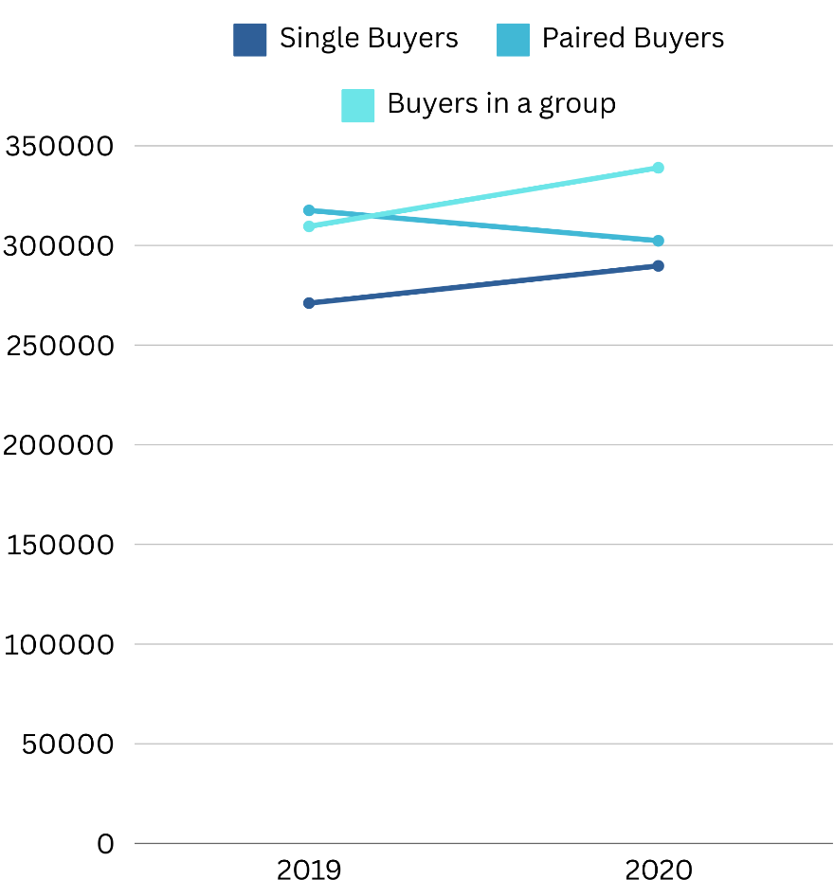

**SQL QUERRY:**

SELECT

g.Buyers_Grp_Type,

AVG(s.Year_2019) AS Avg_Sale_Price_2019,

AVG(s.Year_2020) AS Avg_Sale_Price_2020

FROM

Avg_Sale_Price_Data s

JOIN

Buyers_Group_Type_Lookup g ON s.Grp_ID = g.Grp_ID

GROUP BY

g.Buyers_Grp_Type;

## **The trend in the Number of Buyers Over Time by Province**

The number of buyers significantly increased in New Brunswick between 2019 and 2020, with the province showing a large jump in demand. Meanwhile, Manitoba experienced a relatively stable number of buyers, indicating that market conditions in different provinces are evolving at different rates.

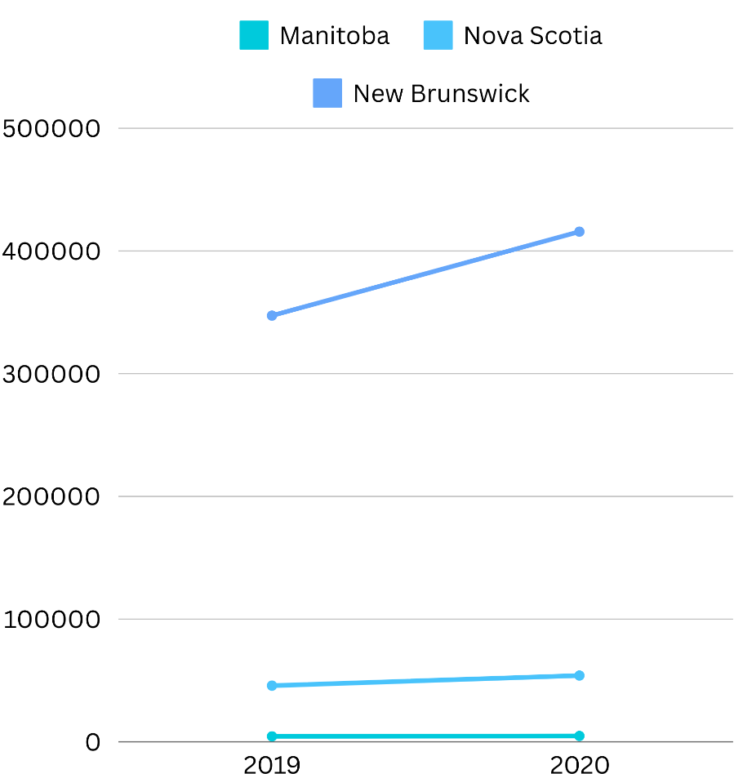

**SQL QUERRY:**

SELECT

p.Province_Name,

SUM(n.Year_2019) AS Buyers_2019,

SUM(n.Year_2020) AS Buyers_2020

FROM

Property_Sold_Num_Data n

JOIN

Province_Lookup p ON n.Province_ID = p.Province_ID

GROUP BY

p.Province_Name;

# **Conclusion**

The analysis reveals key trends in property buyer behavior, income levels, and sale prices across different provinces and demographic groups from 2019 to 2020.

Notably, there was a significant increase in both property sales and prices, particularly among first-time buyers and single buyers. Income disparities persist across different demographic groups, with non-immigrants and males earning higher incomes on average.

Additionally, provinces like New Brunswick saw substantial growth in both income and sales activity. These insights provide a comprehensive understanding of the evolving real estate landscape, highlighting demographic and regional differences in the market.

**SQL Queries for Table Creation & Population**

-- Table for Province Lookup

CREATE TABLE Province_Lookup (

Province_ID INT PRIMARY KEY,

Province_Name VARCHAR(50)

);

-- Table for Average Family Total Income Data

CREATE TABLE Avg_Family_Income_Data (

Province_ID INT,

Grp_ID INT,

Status_ID INT,

Char_ID INT,

Year_2019 DECIMAL(10, 2),

Year_2020 DECIMAL(10, 2)

);

-- Table for Average Sale Price Data

CREATE TABLE Avg_Sale_Price_Data (

Province_ID INT,

Grp_ID INT,

Status_ID INT,

Char_ID INT,

Year_2019 DECIMAL(10, 2),

Year_2020 DECIMAL(10, 2)

);

-- Table for Buyer Characteristics Lookup

CREATE TABLE Buyer_Char_Lookup (

Char_ID INT PRIMARY KEY,

Buyer_Characteristics VARCHAR(50)

);

-- Table for Buyer Status Lookup

CREATE TABLE Buyer_Status_Lookup (

Status_ID INT PRIMARY KEY,

Buyer_Status VARCHAR(50)

);

-- Table for Buyers Group Type Lookup

CREATE TABLE Buyers_Group_Type_Lookup (

Grp_ID INT PRIMARY KEY,

Buyers_Grp_Type VARCHAR(50)

);

-- Table for Property Sold (Num) Data

CREATE TABLE Property_Sold_Num_Data (

Province_ID INT,

Grp_ID INT,

Status_ID INT,

Char_ID INT,

Year_2019 INT,

Year_2020 INT

);

------ ENTERING DATA IN TABLES -------

----- Locating local directory of SQL

SHOW data_directory

------------------------------- LOOKUP TABLES -----------------------------------

----- Province_Lookup Table

INSERT INTO Province_Lookup (Province_ID, Province_Name) VALUES

(1, 'Nova Scotia'),

(2, 'New Brunswick'),

(3, 'Manitoba'),

(4, 'British Columbia'),

(5, 'Yukon');

-- Buyer_Char_Lookup

INSERT INTO Buyer_Char_Lookup (Char_ID, Buyer_Characteristics) VALUES

(1, 'Male'),

(2, 'Female'),

(3, 'Immigrant 20'),

(4, 'Non-immigrant');

----- Buyers_Status_Lookup

INSERT INTO Buyer_Status_Lookup (Status_ID, Buyer_Status) VALUES

(1, 'Not first-time home buyer'),

(2, 'First-time home buyer');

----- Buyers_Group_Lookup

INSERT INTO Buyers_Group_Type_Lookup (Grp_ID, Buyers_Grp_Type) VALUES

(1, 'Single buyer'),

(2, 'Paired buyer'),

(3, 'Buyer in a group of three or more');

------------------------------- DATA TABLES -----------------------------------

----- Avg_Sale_Price_Data

COPY avg_sale_price_data(Province_ID, Grp_ID, Status_ID, Char_ID, Year_2019, Year_2020)

FROM 'C:\Program Files\PostgreSQL\16\data\Average Sale Price Data.csv'

DELIMITER ','

CSV HEADER;

----- Avg_Family_Total_Income_Data

COPY Avg_Family_Income_Data(Province_ID, Grp_ID, Status_ID, Char_ID,Year_2019, Year_2020)

FROM 'C:\Program Files\PostgreSQL\16\data\Average family total income Data.csv'

DELIMITER ','

CSV HEADER;

----- Number_of_Buyers_Data

COPY Property_Sold_Num_Data (Province_ID,Grp_ID,Status_ID,Char_ID,Year_2019,Year_2020)

FROM 'C:\Program Files\PostgreSQL\16\data\Num_of_Buyers_Data.csv'

DELIMITER ','

CSV HEADER;

# **Refrence**

* Government of Canada, Statistics Canada. (2023, December 8). *Residential property buyers: Demographic data, first-time home buyer status, and price-to-income ratio*. https://www150.statcan.gc.ca/t1/tbl1/en/tv.action?pid=4610006201